**Q2. Create an EC2 intance for a Reactjs application and deploy the application and provide the public ip for it, also enable the cloud monitoriing on this estances.**

* **Creating a ubuntu instance**

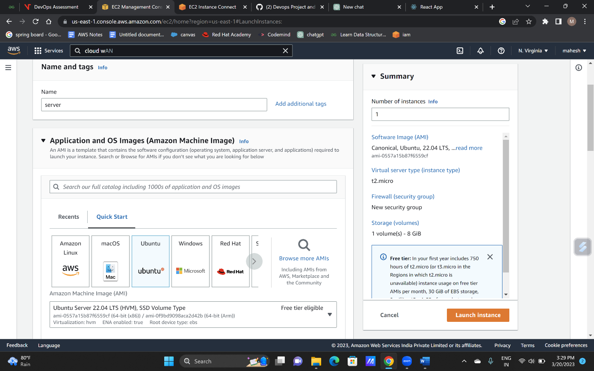

* To update the ubuntu use Command : sudo apt-get update

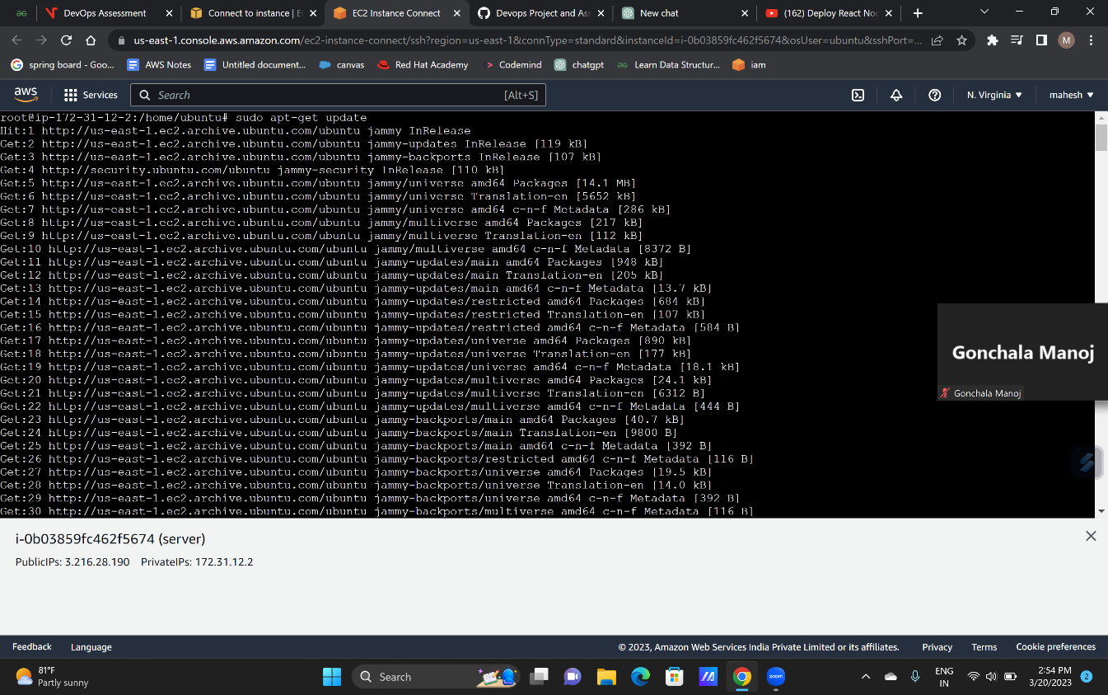

* 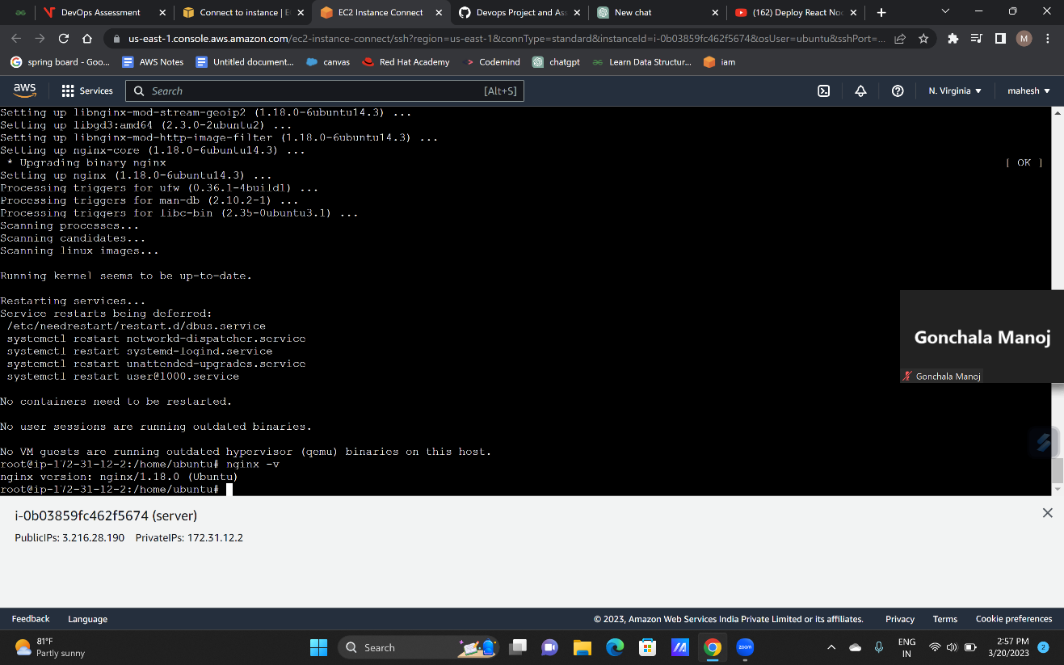sudo apt-get install nginx -y

🡪 To install nodejs use “sudo apt-get install curl” and “sudo apt-get install -y nodejs” commands.

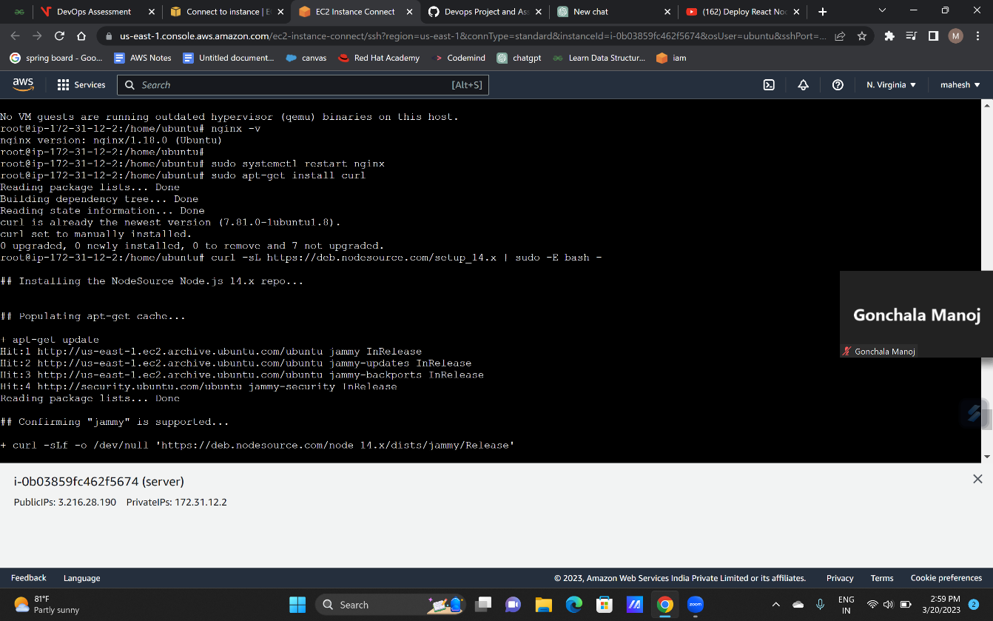

* To create the react project use command “npx create-react-app react-tutorial”

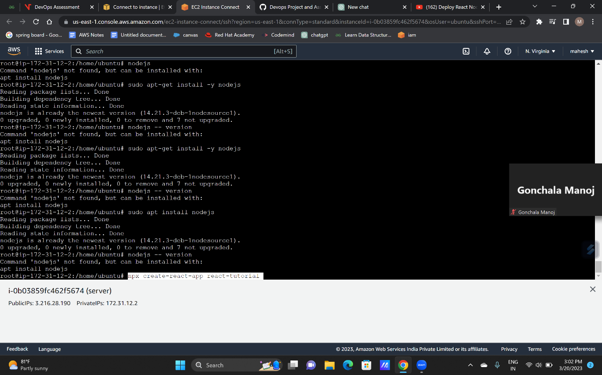

* To build and start :“npm run build “and “ npm start”

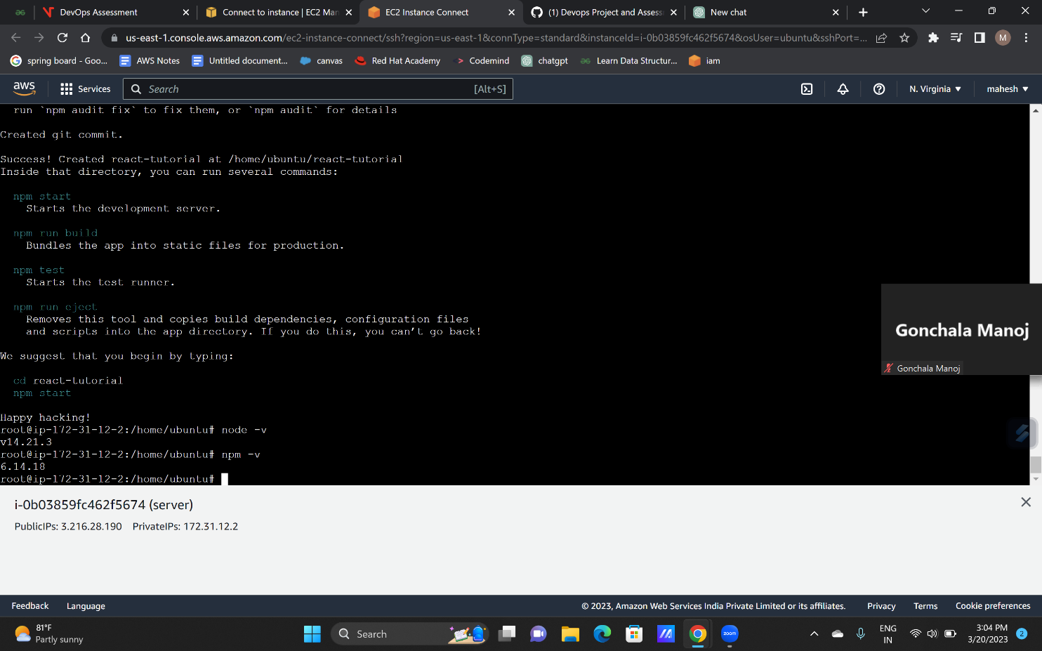

* The 3000 port is assigned to the the reactapp
* The browse the public ip with the assigned port -- “3.216.28.190:3000”

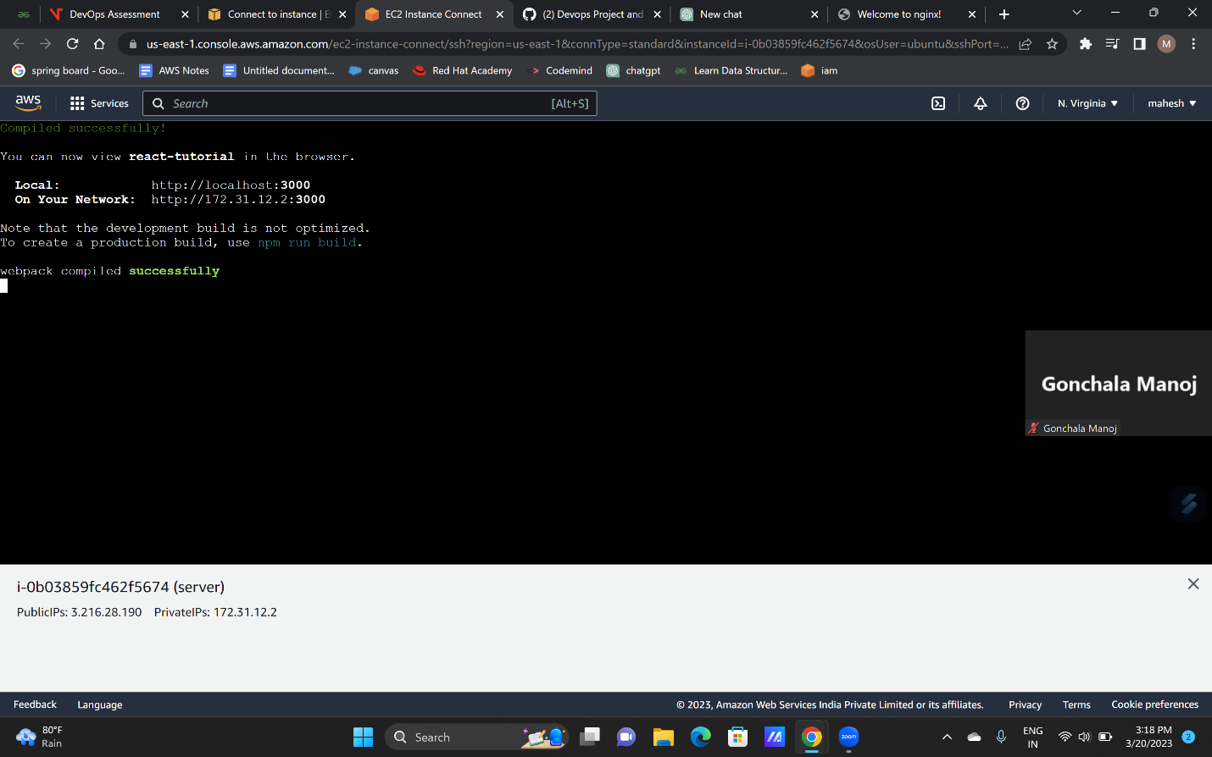

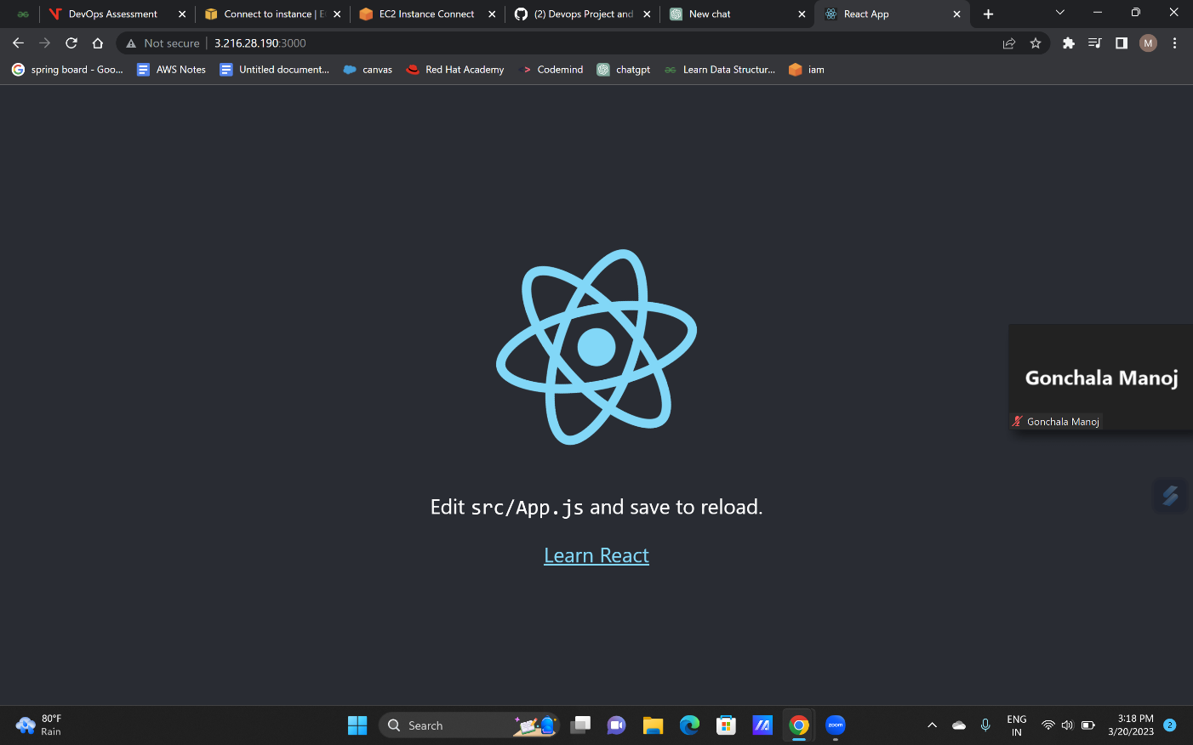

* 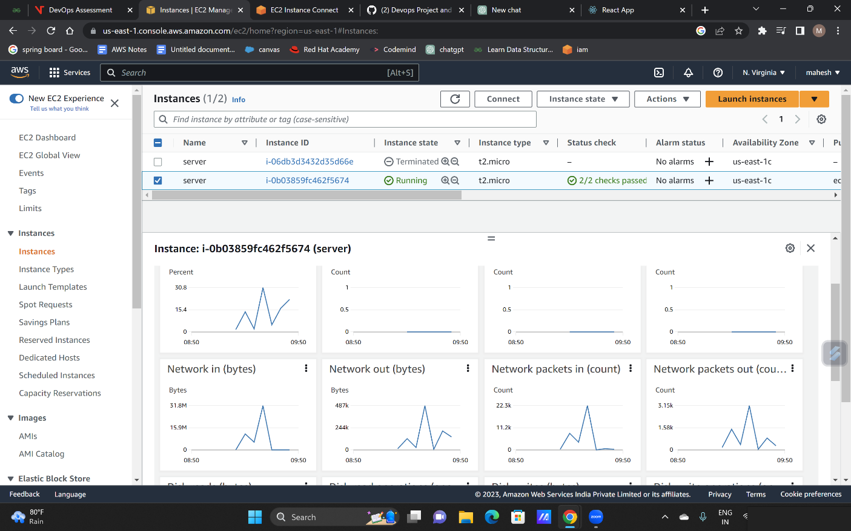Monitoring the reactjs instance